***Light Power***

***Ease of use***

***Software programming***

***Radio frequency communication***

**Green mono color cross**

**Power supply 230V / 50 Hz**

**Hour – Date – Temperature.**

**Scrolling texts**

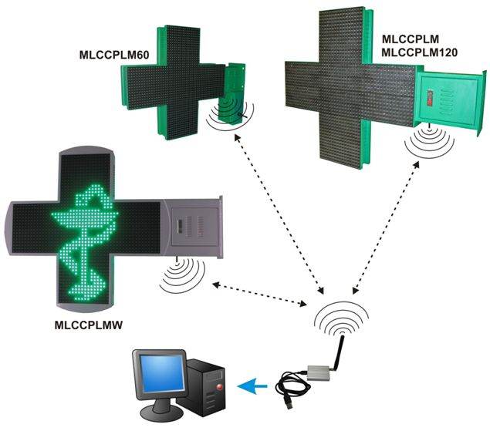

**INTRODUCING**

* Software programming
* Radio Frequence (50 m max open fields)
* Possibility of multi-cross communication
* Create a custom playlist :
* Custom text scrolling
* Text scrolling speed
* Display hour
* Display date
* Display temperature

WARNING : The product warranty can not be applied :

* Installation in a salt atmosphere
* Recommendations for installation not respected

**DOUBLE SIDED CROSS 60 cm**

**Ref : MLCCPLM60**

**Green RAL 6024 mate**

**Pitch : 12,5 mm**

**2560 ovals leds 110°/60° green**

**4000 mcd/led**

**Average consumption (over an animation cycle): 120 W**

**Protection sign : IP 43**

**weight : 13kg**

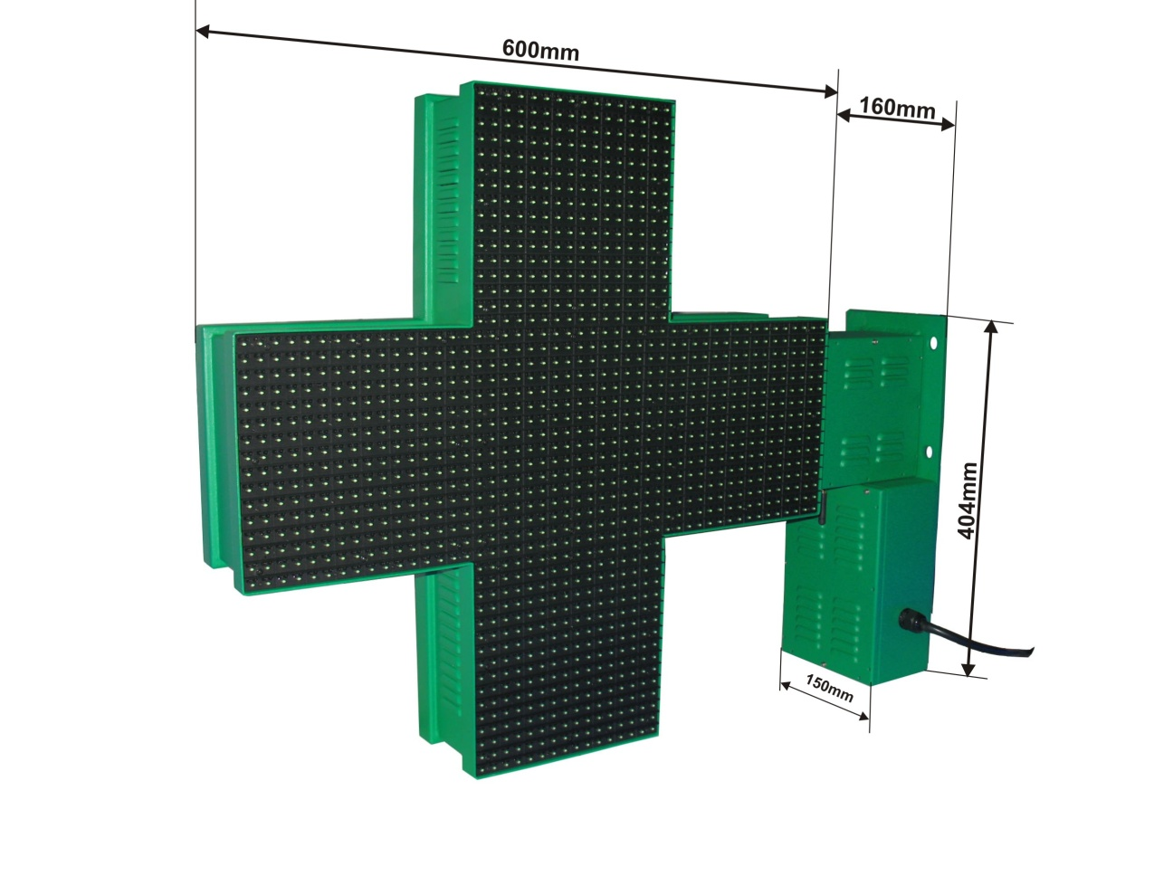

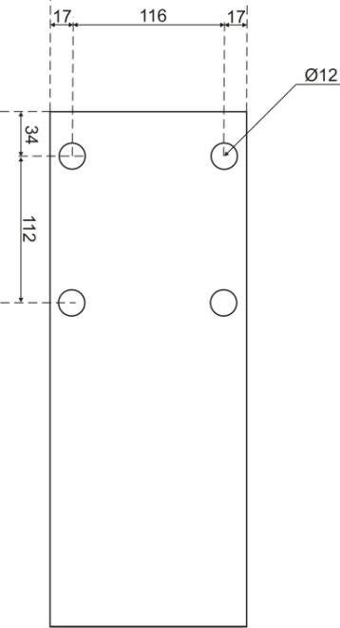

**Mounting feet**

**(Dim in mm)**

**DOUBLE SIDED CROSS 80 cm**

**Ref : MLCCPLM080**

**Green RAL 6024 mate**

**Pitch : 16 mm**

**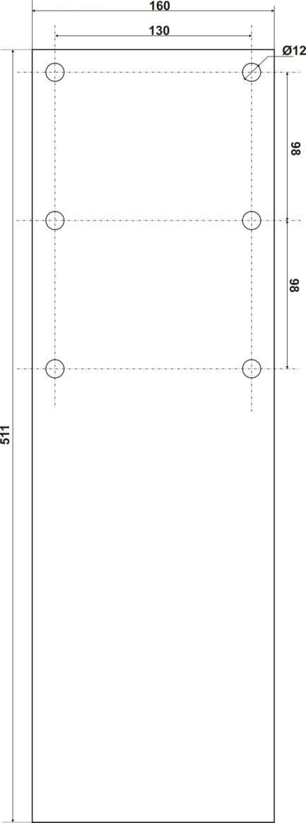**

**2560 ovals leds 110°/60° green**

**4000 mcd/led**

**Average consumption (over an animation cycle): 120 W**

**Protection sign : IP 43**

**Weight : 20kg**

**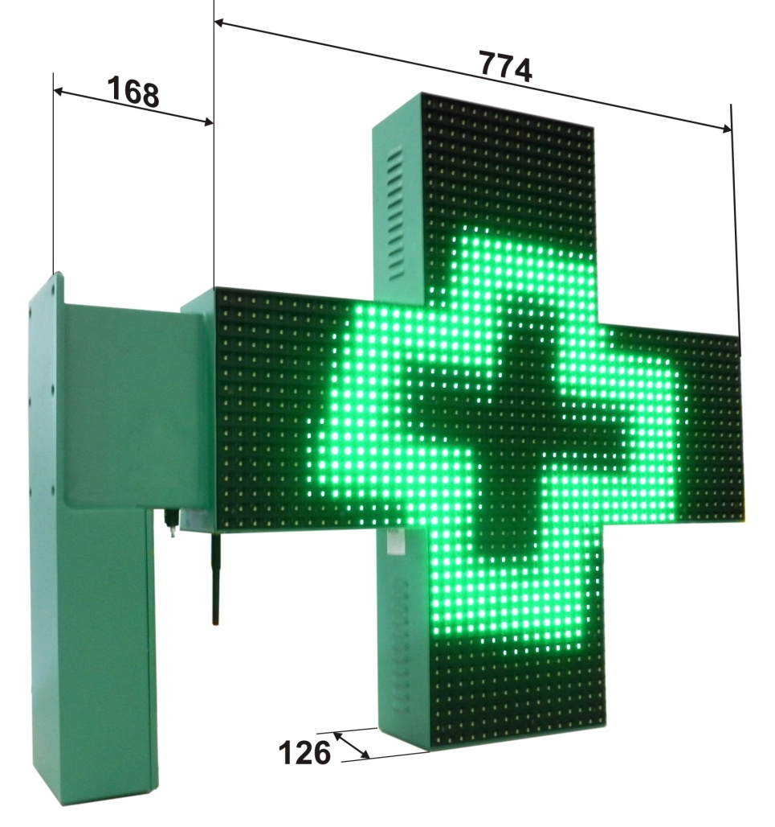**

**Mounting feet**

**(Dim in mm)**

**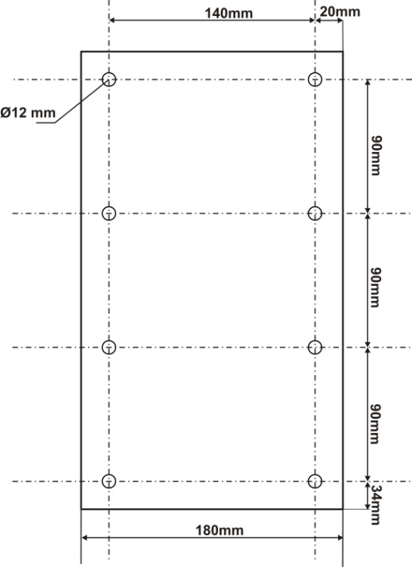DOUBLE SIDED CROSS 100 cm**

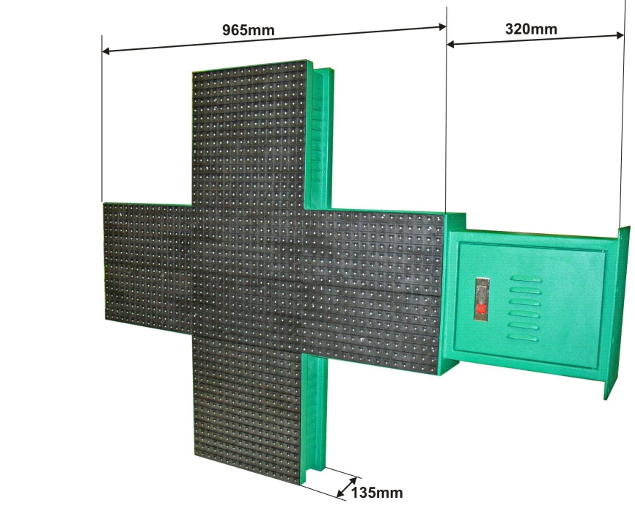**Ref : MLCCPLM**

**Green RAL 6024 mate**

**Pitch : 20 mm**

**2560 lovals leds 110°/60° green**

**4000 mcd/led**

**Average consumption (over an animation cycle): 120 W**

**Protection sign : IP 43**

**weight : 27kg**

**Mounting feet**

**(Dim in mm)**

**SINGLE FACE CROSS 100 cm**

**Ref : MLCCPLMS**

**Green RAL 6024 mate**

**Pitch : 20 mm**

**1280 ovals leds 110°/60° green**

**4000 mcd/led**

**Average consumption (over an animation cycle): 70 W**

**Protection sign : IP 43**

**Weight : 25kg**

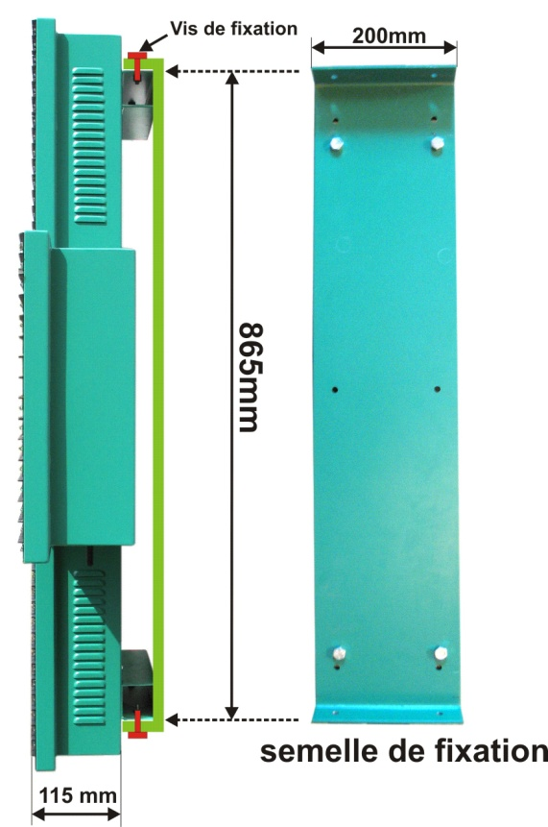

Screw fixing

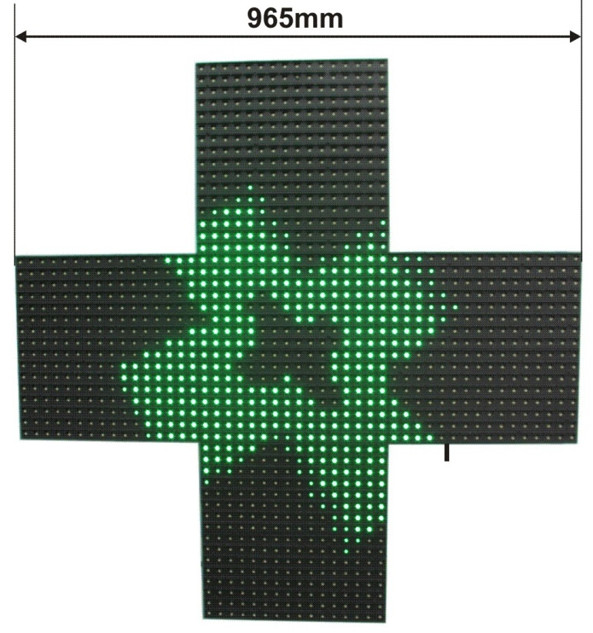

**Mounting feet**

**(Dim in mm)**

**DOUBLE SIDED CROSS 120 cm**

**Ref : MLCCPLM120**

**Green RAL 6024 mate**

**Pitch : 25 mm**

**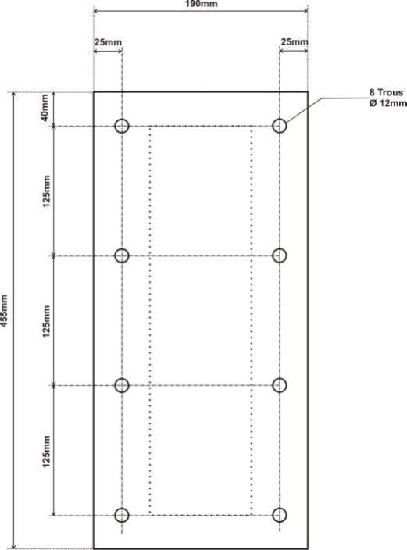**

**2560 ovals leds 110°/60° green**

**4000 mcd/led**

**Average consumption (over an animation cycle): 180 W**

**Protection sign : IP 43**

**Weight : 43kg**

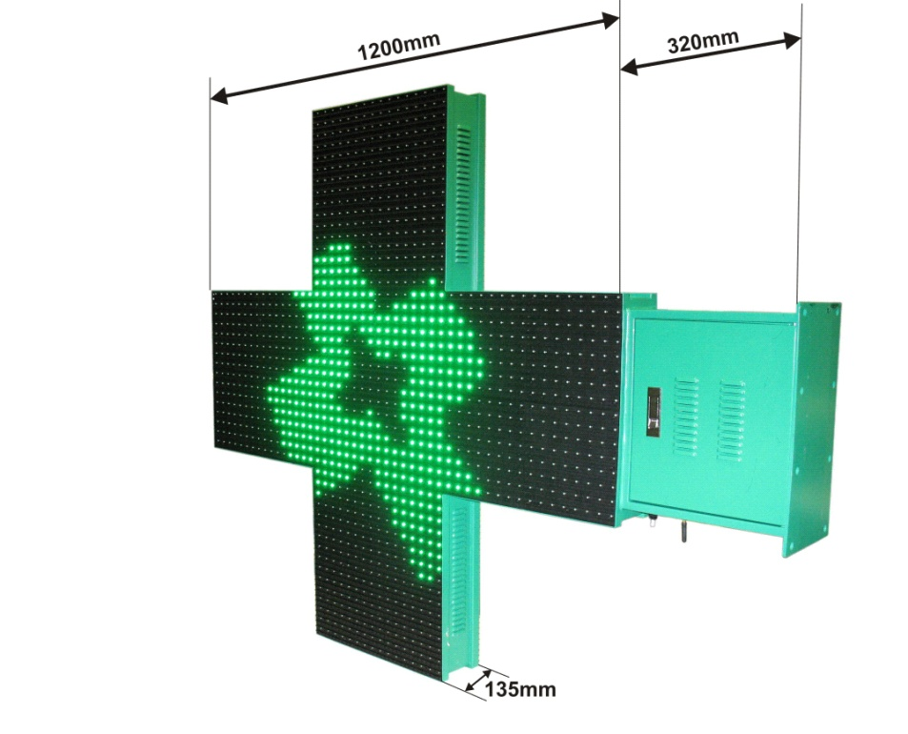

**Mounting feet**

**(Dim in mm)**

**DOUBLE SIDED CROSS 100CM type S**

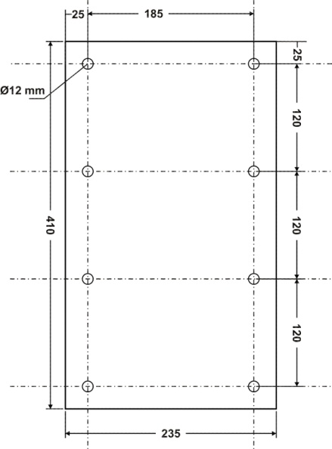**Ref : MLCCPLMW- White frame - RAL 9003**

**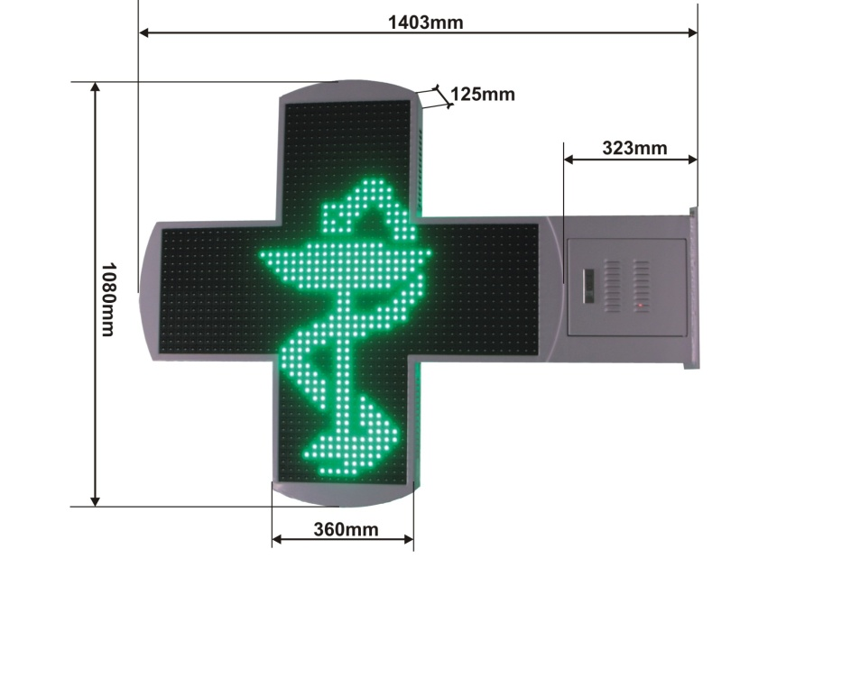Pitch : 20 mm**

**2560 leds ovales 110°/60° vertes**

**4000 mcd/led**

**Average consumption (over an animation cycle): 120 W**

**Protection sign : IP 43**

**Weight : 34kg**

**MLCCPLMW**

**Mounting feet**

**(Dim in mm)**

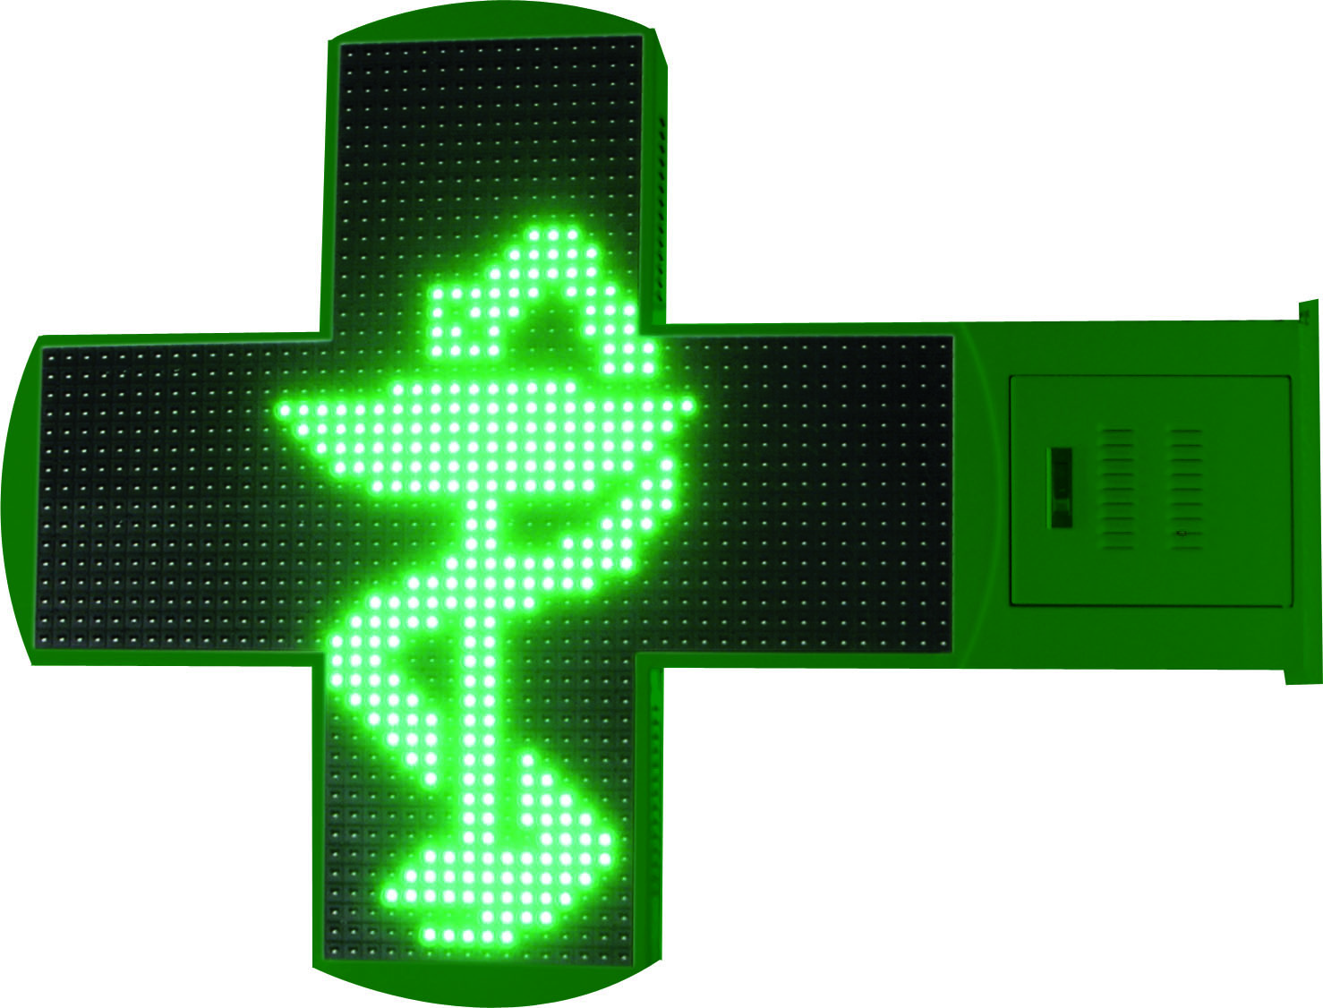

**Ref : MLCCPLMWV – Vert RAL 6024**

**Pitch : 20 mm**

**MLCCPLMWV**

**DOUBLE SIDED CROSS 100 cm**

**Ref : MLCCPLMV**

**Green RAL 6024 mate**

**Pitch : 20 mm**

**2560 lovals leds 110°/60° green**

**4000 mcd/led**

**Average consumption (over an animation cycle): 120 W**

**Protection sign : IP 43**

**weight : 27kg**

**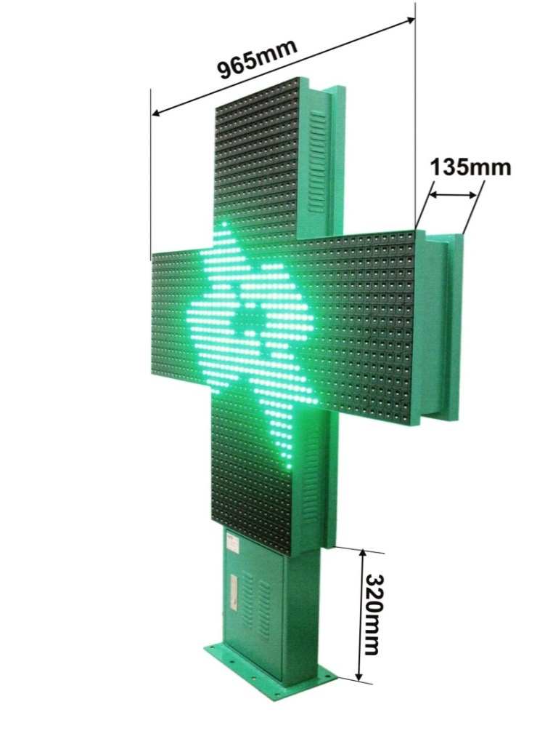**

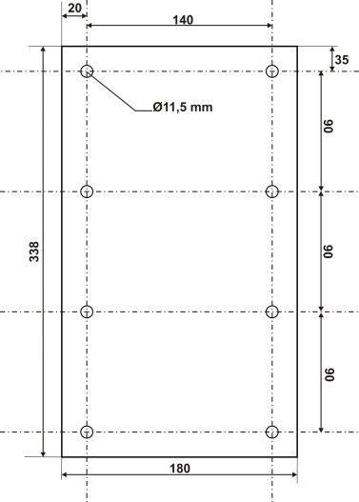

**Mounting feet**

**(Dim in mm)**

**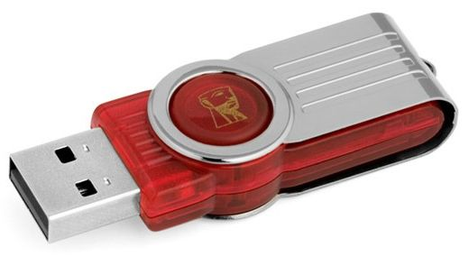ACCESSORIES**

**1 – USB installation key**

**Computer configuration required :**

* Windows XP, VISTA, 7, 8, 10 in admin mode.
* The PC has to have a minimum resolution screen of 1024 X 768 pixels

(Notebooks with1024 x 600 pixels are not compatibles)

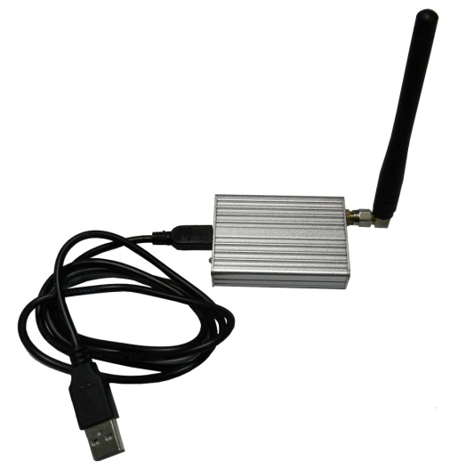

**2 –** **Radio Fréquence Module**

**IMPORTANT :**

The RF module has to be connected after the software installation

**3 – Antenna**

2 antennas are delivered with the cross

* 1 for the RF module
* 1 for the cross **(WARNING : If the antenna is not connected, the cross can’t communicate)**

**SOFTWARE (Windows XP, VISTA, 7, 8, 10 ready )**

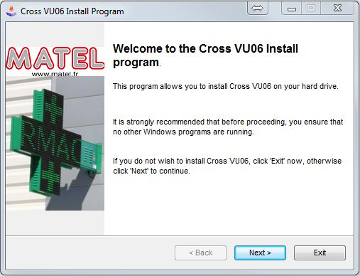

1. Connect the usb key to the pc
2. Open the « CROSS\_VU06\_G » folder
3. Clic on « INSTALL.EXE », the installation software will begin
4. Follow the instructions. The cross softwareis installed

1. The RF module’s driver installation will start

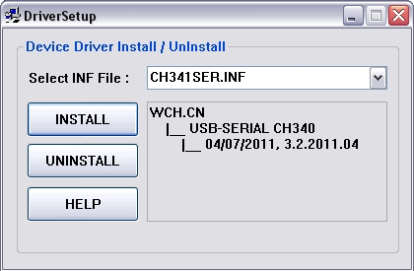

1. Connect the RF module to the PC, Windows will recognize the RF module automatically

**WARNING : The RF module has to be connected before the software’s launching**

**1 – COMMUNICATION WITH THE CROSS**

The first thing to do is to check and select the usb key’s port com in the software.

**WARNING : if the port com number is not the good one, the software will not be able to communicate with the cross.**

* **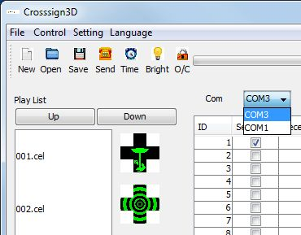to identify the good port com :**

1. Unplug the RF module from the PC
2. Close the software and re-execute it
3. Check the number of port com available in the software window. There are some port com numbers.
4. Close the software
5. Plug the RF module to the PC
6. 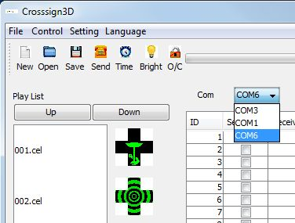Execute the software
7. Check the number of port com available in the software window. The RF module’s port com number will appears and be added to other port com.

An alternative way to check the RF module port com is to go to the windows device manager :

1. 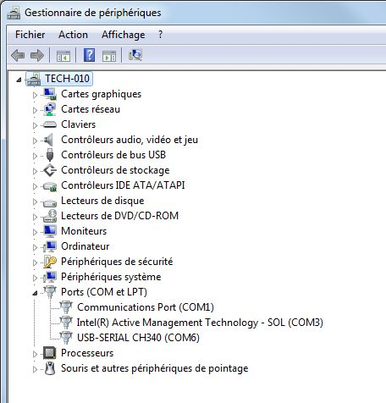Open the window start menu
2. In the searching bar type “windows device manager”
3. Look for “Ports (Com et LPT)”
4. Clic on the “+”
5. The name of the driver is USB-SERIAL CH340 the port com number is next to the name.(Com x)
6. 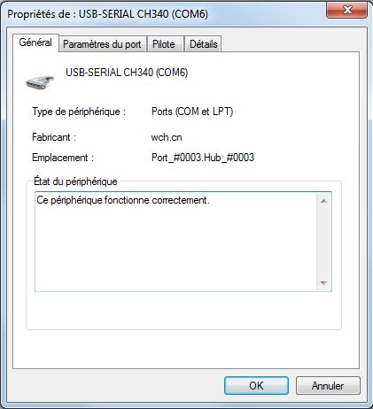Double clic on : USB-SERIAL CH340 to open the port com property
7. Check if the device is working properly

**2 –** **Software functions**

**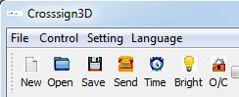**

**« Language menu »:** allow to change the language of the software

**« New »:** create a new playlist

**« Open »:** open a playlist

**« Save»**: Save a playlist

**« Send »**: Send the playlist to the cross

**« Hour »**: update the cross hour

C:\Users\cfaure\Desktop\notice anglais\icone_lum.jpg

**« Brightness »** :

There are two brightness modes

Automatic mode: «Automatic control»

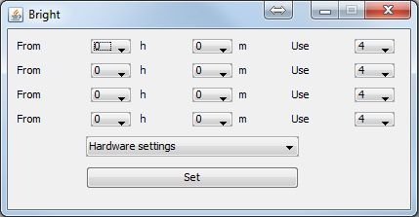The brightness level is automatically update thanks to a brightness sensor. Confirm and select the automatic mode and click on set

The manual mode: “software parameter”

Allow to set the brightness on 8 level (1 to 8, low to high level) and on 4 different periods on 24H

It is possible to adjust the brightness 1 to 8 directly when all hour boxes are at 0. Clique on Set to confirm the cross brightness

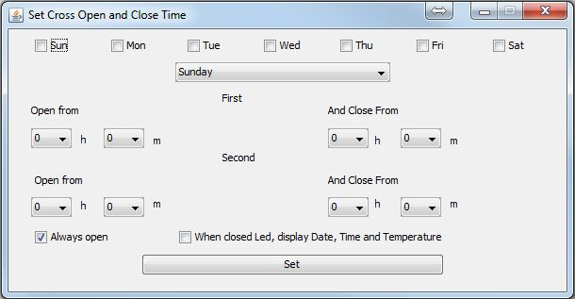**« O/C »**: ouvert_ferme

Broadcast time slot.

* It is necessary to choose the days the cross is running, ticking the boxes ( from Sunday to Saturday)
* 2 time slot can be defined
* When the box **« when closed led, display date, time and temperature »** is ticked, only the date, hour and temperature will be displayed apart from opening hour
* When **« always open »** is ticked, the cross will running 24/24
* Don’t forget to click on **« Set »** to send the modification to the cross.

**3 – Create a play list**

By default an animation list is available and appears in the reserved area for this purpose.

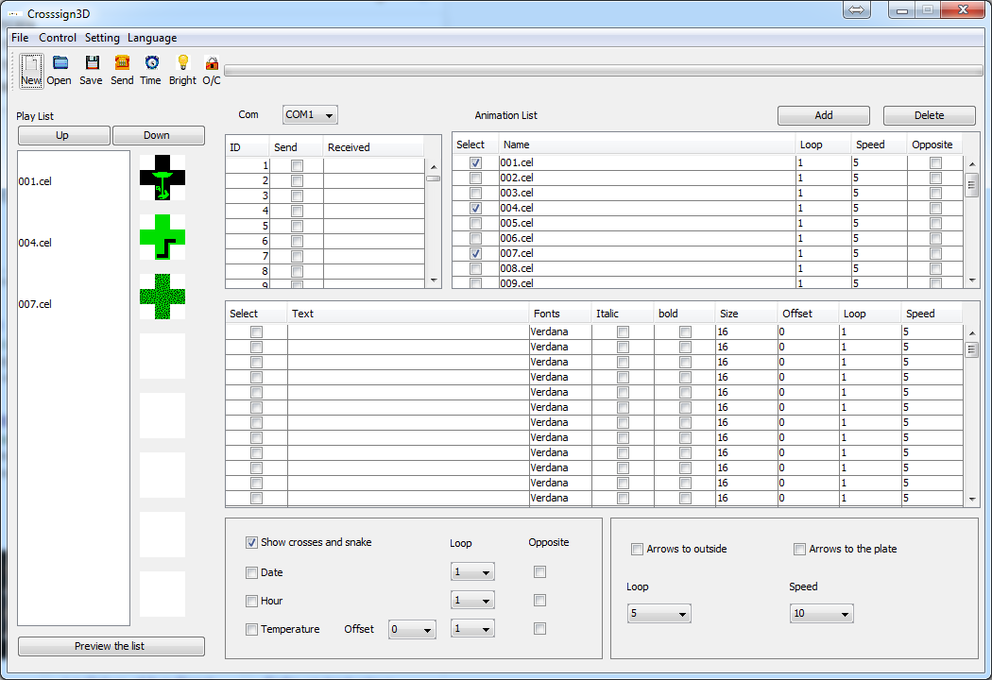

Simply tick the animation needed to make it appear in the play list. Untick the animation to make it disappear from the playlist.

Each animation can be repeated X time. 1 loop = 2 second.

It is possible to set the speed of each animation on 31 levels. The 1st level is faster than 31th one.



Animations can be added from the folder « animation » clicking on “add”.

It is possible to delete an animation from the animation list clicking on “delete”.

A preview of an animation is displayed by double clicking on the animation name in the play list.

The order of animations in the playlist can be changed clicking on “up” and “down”.

There is a preview of the playlist by clicking on “preview the list”.

The playlist can be saved clicking on file =>save or save as. The file will be save in the « SET » folder at C:\Croix\_VU06

**WARNING**

By clicking on « new », the playlist disappear and the animation list too.

The animation list can be find in the animation folder. Click on “add” to choose the animation to add in the animation list.

* Do not use « arrow-left.cel » , « arrow-right.cel » and «  Back.cel »
* Do not delete the animation in the animation folde

**4 – Display a text**

There are several empty field provided for text writing.

Font, Character high and scrolling speed can be set.

It is possible to set the speed of each animation on 31 levels. The 1st level is faster than 31th one.

The offset of the text can be set too.

Tick the “select” box to add the text to the play list.

Double click the name of the animation in the playlist open a preview.

**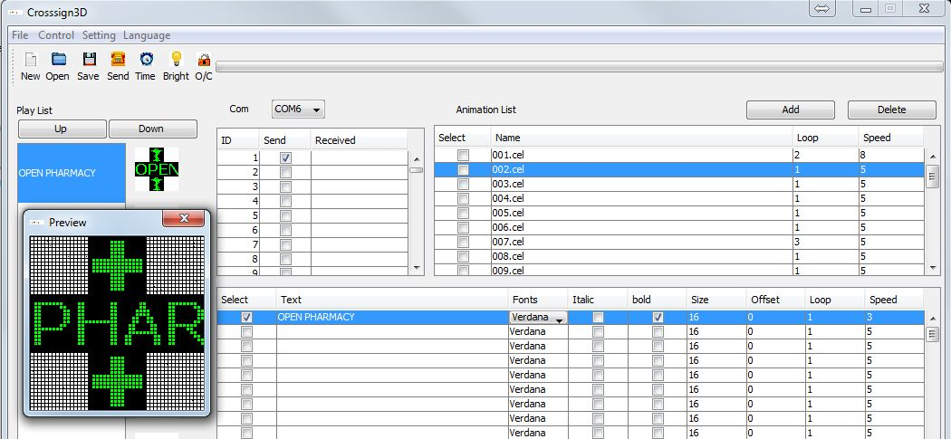**

**5 – Display hour, date, temperature**



Hour, date and temperature can be displayed on the cross.

Just tick the boxe(s) you need.

You can select the number of loop for each value (1 loop = 2 sec).

The offset of the T°C can be set to +/- 10°C.

The “show crosses and snake” boxe display little snake + crosses.

The “opposite” boxe invert the displaying.

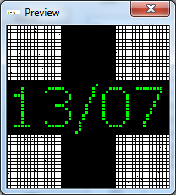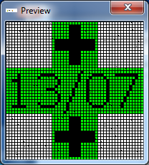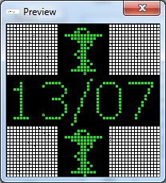

With crosses and snake without crosses and snake opposite

**6 – Display arrow « Parking »**

Tick the direction of arrows. Set the loop and speed.

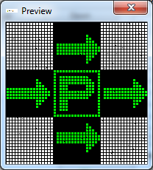

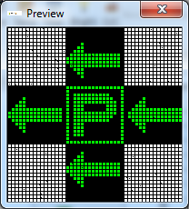

**7 – Send the playlist to the cross**

**C:\Users\cfaure\Desktop\notice anglais\icone _envoie.jpg**

Tick the box number corresponding to the cross ID number.

Click on send to send the play list to the cross.

To determine the cross ID number, refer to p12.

A progress bar will appears, the software is sending data to the cross and the job will be done when the progress bar will be full.

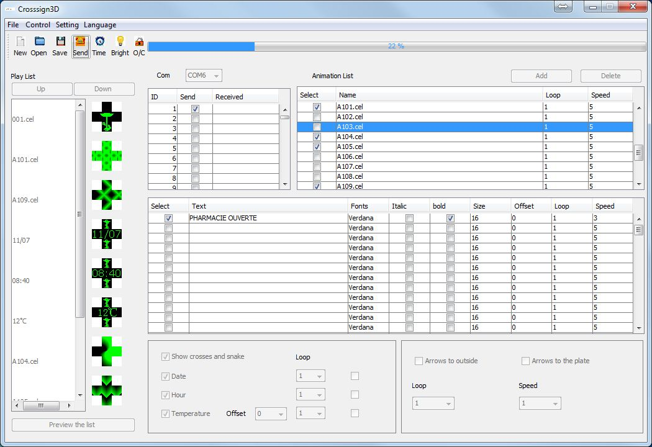

**Parking‘s direction arrows selection**

**Progress bar**

**Tick the cross id number**

**Note :**

During the data send, the cross will shut down. At the end of the transfer the received column will display a message in front of the ID number :

“OK” if the playlist has been send correctly.

“ERROR” if the playlist has not been send correctly.

**Send the playlist to several crosses simultaneously:**

The data can be send at the same time on many crosses if you ticked the IDs’s crosses numbers boxes.

**C:\Users\cfaure\Desktop\notice anglais\phot9.jpgHour update:** Sending the playlist doesn’t set the correct hour on the cross. To send the correct hour to the cross the time button has to be clicked.

**Note:**

The winter time/summer time hour change will be done automatically if the cross is under power when the changement has to be done.

**Warning :**

Because of the cross memory, if some animation are truncated or displayed, the animation numbers must be reduced.

**IDENTIFY THE CROSS ID NUMBER**

The identification number is on the packaging of the cross, on the cross control card and also on a stickers on the cross.

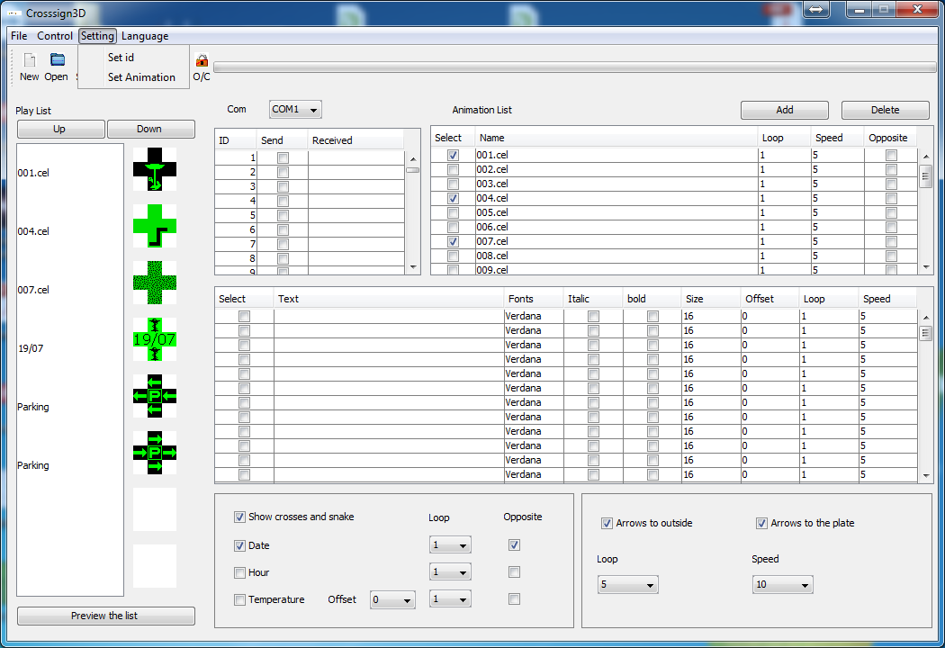It is possible to determine the id number thanks to the “set id” software. Power on the cross. Select the good port com in the software:

Launch the ID software

The window below pop:

**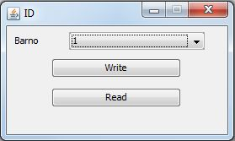**

**To know the id number =>** click on « Read ». The Barno number will change and take the id numbers of the cross.

**To set an ID number to the cross =>** Click on “Write”. The Barno number will be the id number of the cross.

**WARNING**

If there are many crosses in the perimeter:

Clicking on “write” will write the ID number on all crosses of the perimeter

Clicking on “Read” will read the ID number on all crosses of the perimeter. We will not be able to know which one cross ID is for which cross. All crosses has to be power off except for the cross you want to know the ID.

**CREATE AN ANIMATION**

1. From a GIF

An animation can be create from a .gif file.

Click on “set animation” software.

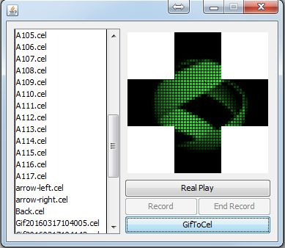

The windows of the software pops,

Click on “GifToCel”,

Click on the .gif file wanted.

The .gif file will be automatically converted in a .cel file. This new file will be added in the animation folder.

The new animation can be added to the animation list of the software clicking on add. (p9)



1. From a screenshoot

Click on “set animation” software.

Click on “Real Play”

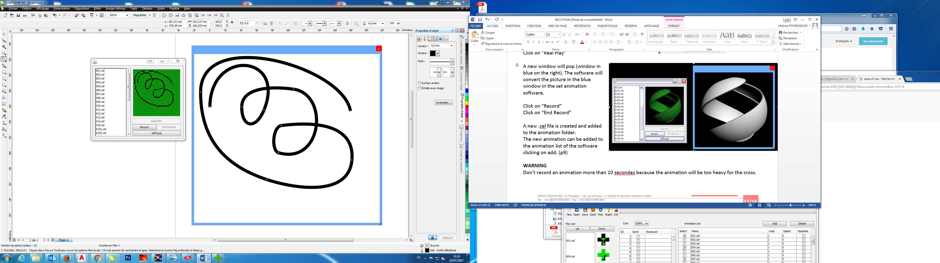

A new window will pop (window in blue on the right). The software will convert the picture in the blue window in the set animation software.

Click on “Record”

Click on “End Record”

A new .cel file is created and added to the animation folder.

The new animation can be added to the animation list of the software clicking on add. (p9)

**WARNING**

Don’t record an animation more than 10 seconds because the animation will be too heavy for the cross.

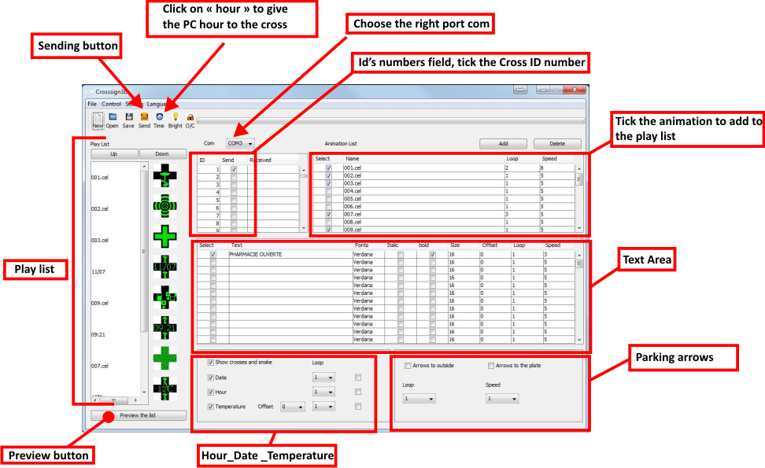

# UE DECLARATION OF CONFORMITY

**Products identification** :

Products type : Led pharmacie cross 60/100/120 cm

Models : MLCCPLMx

We, the undersigned MATEL Group SAS, hereby declare, in accordance with the manufacturer's data, that the products to which this declaration refers comply with the essential requirements of the following European Directives:

LOW VOLTAGE Directive:

2014/35/UE

EMC Directive:

2014/30/UE

The conformity of the products was assessed by applying the following standard (s) :

* EN60950-1 : 2006 + A11 : 2009 + A1 : 2010 + A12 : 2011 + A2 : 2013

Test report N° NTC1406834SV01

* EN55032 : 2015
* EN55024 : 2010 + A1 : 2015
* EN61000-3-2 : 2014
* EN61000-3-3 : 2013

Test report N° NTC1406833EV01

Subject to installation, maintenance and use in accordance with their intended use, the regulations and standards in force in the country of installation, manufacturer's instructions and good engineering practices.

Saint Quentin Fallavier,

July 19, 2017.



# DECLARATION OF CONFORMITY

*RoHS*The undersigned MATEL,

Registered at

*18 rue d’Anjou*

*ZI Tharabie*

*F - 38291 St QUENTIN FALLAVIER*

*FRANCE*

Declare by our sole responsibility, that these products:

* **Led pharmacie cross** **60/100/120cm**

Where appropriate, are in conformity with the RoHS directive2011/65/EU.

Test report n° DGC140807002A

Saint Quentin Fallavier,

July 19, 2017

